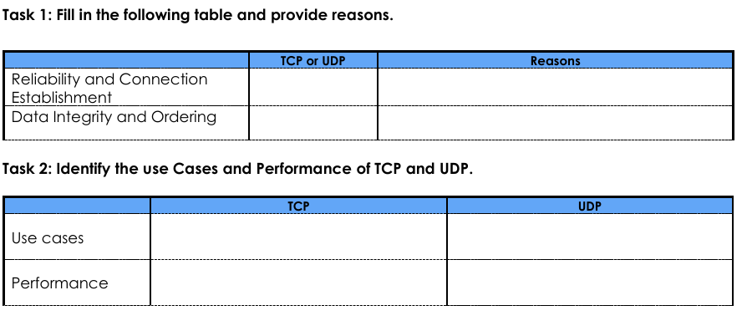

Faster then tcp but less reliable

Reliable for data transmission and communication

Video streaming

Web browsing

TCP detects errors and try to transfer again

TCP

TCP

Tcp ensure data sent is received in order.